**Brain Tumor Segmentation with Clara Deploy Pipeline**

We will use the installed Clara deploy SDK (refer to previous posts to install Clara Deploy in AWS) to run a brain tumor segmentation pipeline. We will use the clara ngc segmentation model for this purpose (ref - <https://ngc.nvidia.com/catalog/resources/nvidia:clara:clara_ai_brain_tumor_pipeline>)

Create a pipeline folder and pull the pipeline from ngc

clara pull pipeline clara_ai_brain_tumor_pipeline

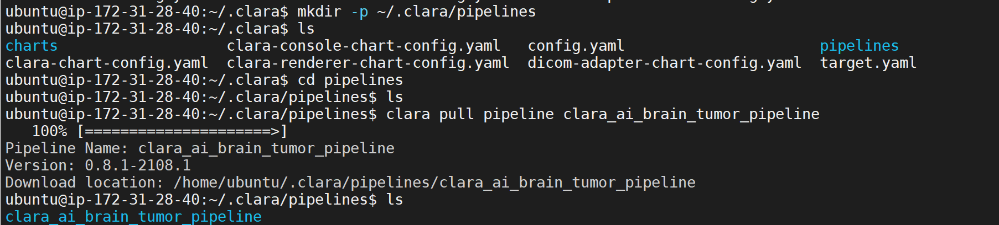

Unzip the input dicom series



Unzip the model



Register the model

clara create model -p segmentation_mri_brain_tumors_br16_t1c2tc_v1/ -t tensorflow



Create the pipeline

clara create pipeline -p brain-tumor-pipeline-model-repo.yaml



Create and start the job

clara create jobs -n brain-test -p b8703c88407848a48a58496ef411daee -f ~/.clara/pipelines/clara_ai_brain_tumor_pipeline/dcm



Check the Clara Console in localhost:32002 and take the output download of the job.

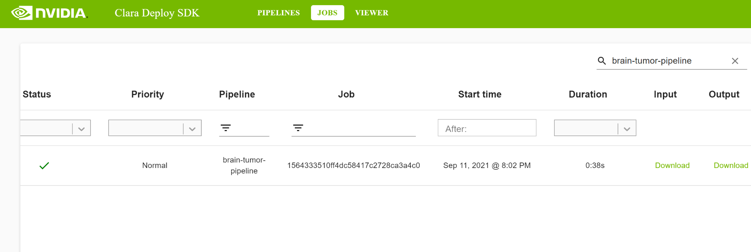

View the output in 3d-slicer-segmented tumor

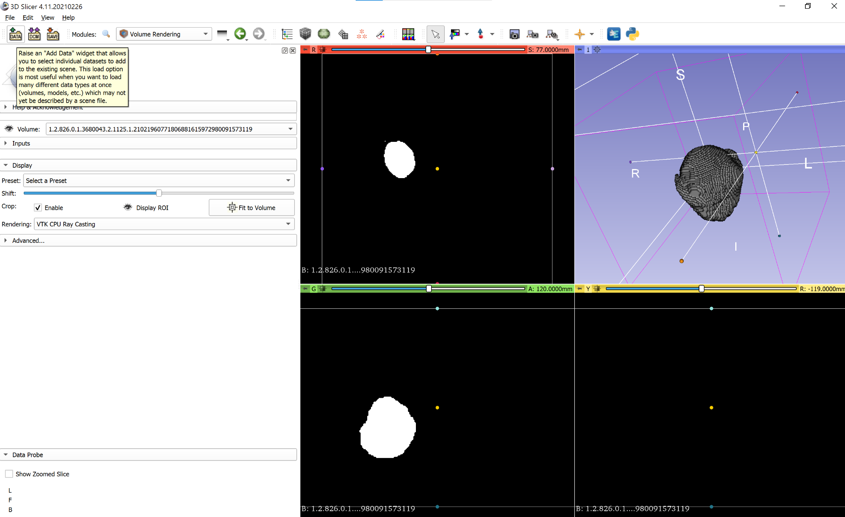

Location of the tumor through rendering

